Preliminary Research:

As stated in the previous section we will be exploring how to predict Apple stock volatility by using machine learning and other models on the Yahoo Finance dataset. In order to accurately model the data, it is important to research and draw inspiration from published papers in similar topics.

The first article [1] describes the use of time series data, (in our case Apple stock data), modeled by 4 different models: Autoregressive Model (AR(p)), Moving Average Model (MA(q)), Autoregressive Moving Average Model (ARMA(p,q)), and the Autoregressive Integrated Moving Average Model (ARIMA(p,d,q)). The paper further discusses how the ARIMA model takes into account seasonality and trend for time series data in order to ensure that the model is stationary. To determine if a model is stationary, we will need to use the Auto-Correlation Function (ACF) and Partial Auto-Correlation Function (PACF). If p values for these functions are less than 0.05 or 5%, then a series is said to be stationary. 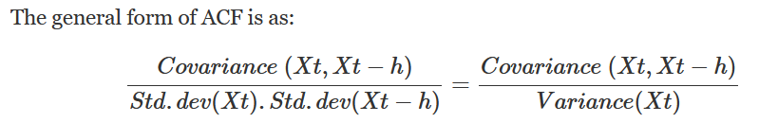

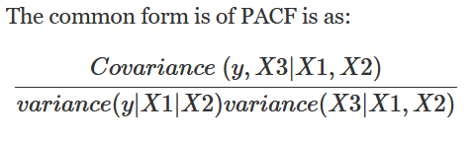

The second article [2] talks about the important of the CBOE Market Volatility Index (VIX) and how to interpret volatility as a financial measurement. In this article the authors describe the volatility index as being bases on volatility “changes” as represented by the equation below.



There are 3 things to consider when thinking about the volatility index: 1) The variable of interest are the changes to expected volatility. 2) If stock prices are random, then the estimate of the relationship between stock and volatility indexes is false. 3) VIX levels are defined to be random, with a daily VIX level first-order autocorrelation of 97%.

The third article explains the authors’ implementation of Support Vector Machine (SVM) and Radial Basis Function (RBF) models in order to predict future stock price or volatility of prices or market trend. By using stock price volatility, stock momentum, index volatility, and index momentum as features in the SVM model, the authors were able to predict stock prices with high efficiency. Although the authors did not share the exact implementation of the models, they vouch for SVM’s effectiveness for this topic because SVM works on large dataset values and does not have a problem with overfitting the data.

Sources:

[1] Idrees, Sheikh Mohammad, M. Afshar Alam, and Parul Agarwal. "A prediction approach for stock market volatility based on time series data." *IEEE Access* 7 (2019): 17287-17298.

[2] Fleming, Jeff, Barbara Ostdiek, and Robert E. Whaley. "Predicting stock market volatility: A new measure." *Journal of Futures Markets* 15.3 (1995): 265-302.

[3] Reddy, V. Kranthi Sai. "Stock market prediction using machine learning." *International Research Journal of Engineering and Technology (IRJET)* 5.10 (2018): 1033-1035.